ROGER RICKARD BIO
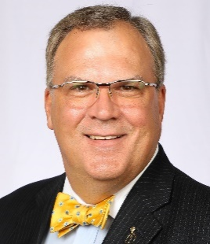

Roger knows that successful advocacy can change the world, it is his life’s work as the Founder & President of Voices in Advocacy® and author of 7 Actions of Highly Effective Advocates and the host of the Voices in Advocacy Podcast.

He has more than 30 years of experience as an advocacy professional where his experience spans a wide cross-section of local, regional, national and international organizations; from such diverse industries as agricultural, financial, medical, and construction, to name a few.

He has served in numerous industry associations’ leadership roles, is a recipient of several international industry awards, and is a member of Meeting Professional International’s prestigious “Community of Honoree’s”.

He is often interviewed by radio, print and television media, highlighted by the MSNBC show Your Business. Smart Meetings Magazine did a cover story on Roger, entitled Passion & Purpose, Roger Rickard’s Call to Action. Successful Meetings Magazine named Roger one of the Six People Worth Watching in the Meetings Industry. Meetings Focus Magazine named him to their inaugural list of Meetings Trendsetters and Connect Magazine named him to their inaugural list of 15 over 50.

Roger is a BIG man at 6’8”, a BIG thinker, and he has BIG ideas for helping you succeed with advocacy. He is casually known as the BIG GUY with a BOW TIE.

